Lost Coast Camp Holiday Newsletter
December 21, 2022
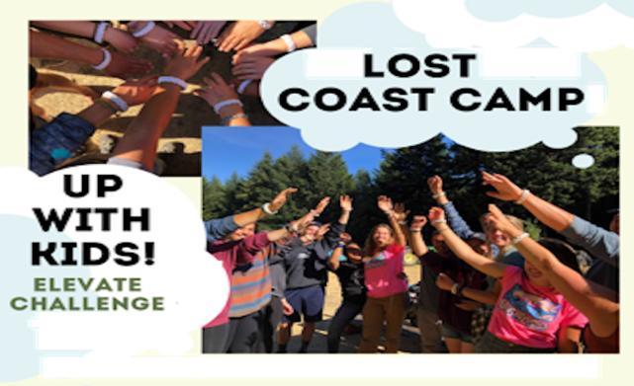
Calling Campers and Staff
Did you know that the fantastic new LCC Lodge is rising here on 7B Ranch? Are you waiting to sign up as a camper or counselor for LCC 2023? Registration opens February 1. We need you to join us in 2023 and keep the best traditions thriving.
Josie and Farmer John
www.lostcoastcamp.org and 707-498-7732
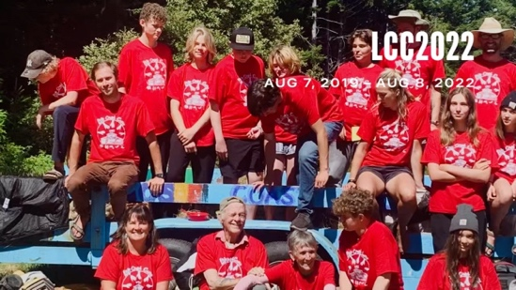

https://youtu.be/-YWqtk01qGM

